**Experiment Title – 2.2**

**Student Name:** YANA SRIVASTAVA **UID:** 20BCS2279

**Branch:** BE-CSE **Section/Group:** 20BCS-WM-906/B

**Semester:** 5th  **Date of Performance:** 04/10/2022

**Subject Name:** PBLJ LAB **Subject Code:** 21 CSP-321

**1. Aim/Overview of the practical:** Playing cards during travel is a fun filled experience. For this game they wanted to collect all four unique symbols. Can you help these guys to collect unique symbols from a set of cards?

Create Card class with attributes symbol and number. From our main method collect each card details (symbol and number) from the user.

Collect all these cards in a set, since set is used to store unique values or objects.

Once we collect all four different symbols display the first occurrence of card details in alphabetical order.

**2. Software/Hardware Requirements:** IntelliJ

**3. Algorithm/pseudo code:**

Step1: create class Main.

Step2: in main method create list of integer name card value.

Step3: apply hashmap map.

Step4: make variable first Entry.

Step5: check the frequency of cards.

Step6: if it is more than 1 then print not unique.

Step7: If it is 1 then unique.

**4. Steps for experiment/practical/Code:**

package com.chirag;

import java.util.Scanner;

import java.util.Set;

import java.util.TreeSet;

//Card class implementing Comparable for storing it in TreeSet

class Card

implements Comparable<Card> {

char symbol;

int number;

public Card(char s, int n) {

this.symbol = s;

this.number = n;

}

@Override

public String toString() {

return symbol + " " + number;

}

@Override

public int compareTo(Card o) {

return (this.symbol - o.symbol);

}

} public class Main {

public static void main(String[] args) {

try (Scanner sc = new Scanner(System.in);)

{

System.out.println("Enter number of cards: "); int n = sc.nextInt();

sc.nextLine();

Set<Card> cards = new TreeSet<Card>();

for (int i = 0; i < n; ++i) {

System.out.println("Enter card " + (i + 1) + ":");

char s = sc.next().charAt(0);

int num = sc.nextInt();

sc.nextLine();

cards.add(new Card(s, num));

}

System.out.println(cards.size() + " sybmols gathered in " + n + " crads");

System.out.println("Crads in set are: ");

for (Card card : cards) {

System.out.println(card.toString());

}

}

}

}

**5. Result/Output/Writing Summary:**

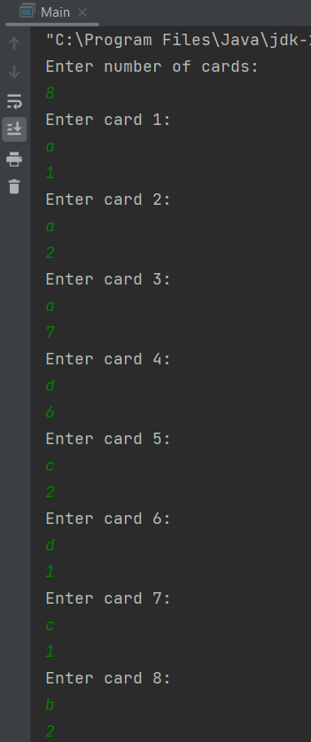

***SCREENSHOT - 1***

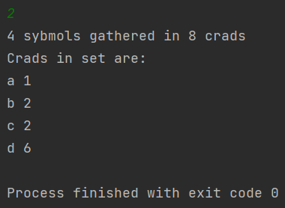

***SCREENSHOT - 2***

**Learning outcomes (What I have learnt):**

1. **Using class and objects in java.**
2. **Using Comparable in java.**
3. **Using TreeSet Handling in java.**
4. **Using for-each loop in java.**